Pizza Dough – Yield: One 14 inch Pizza
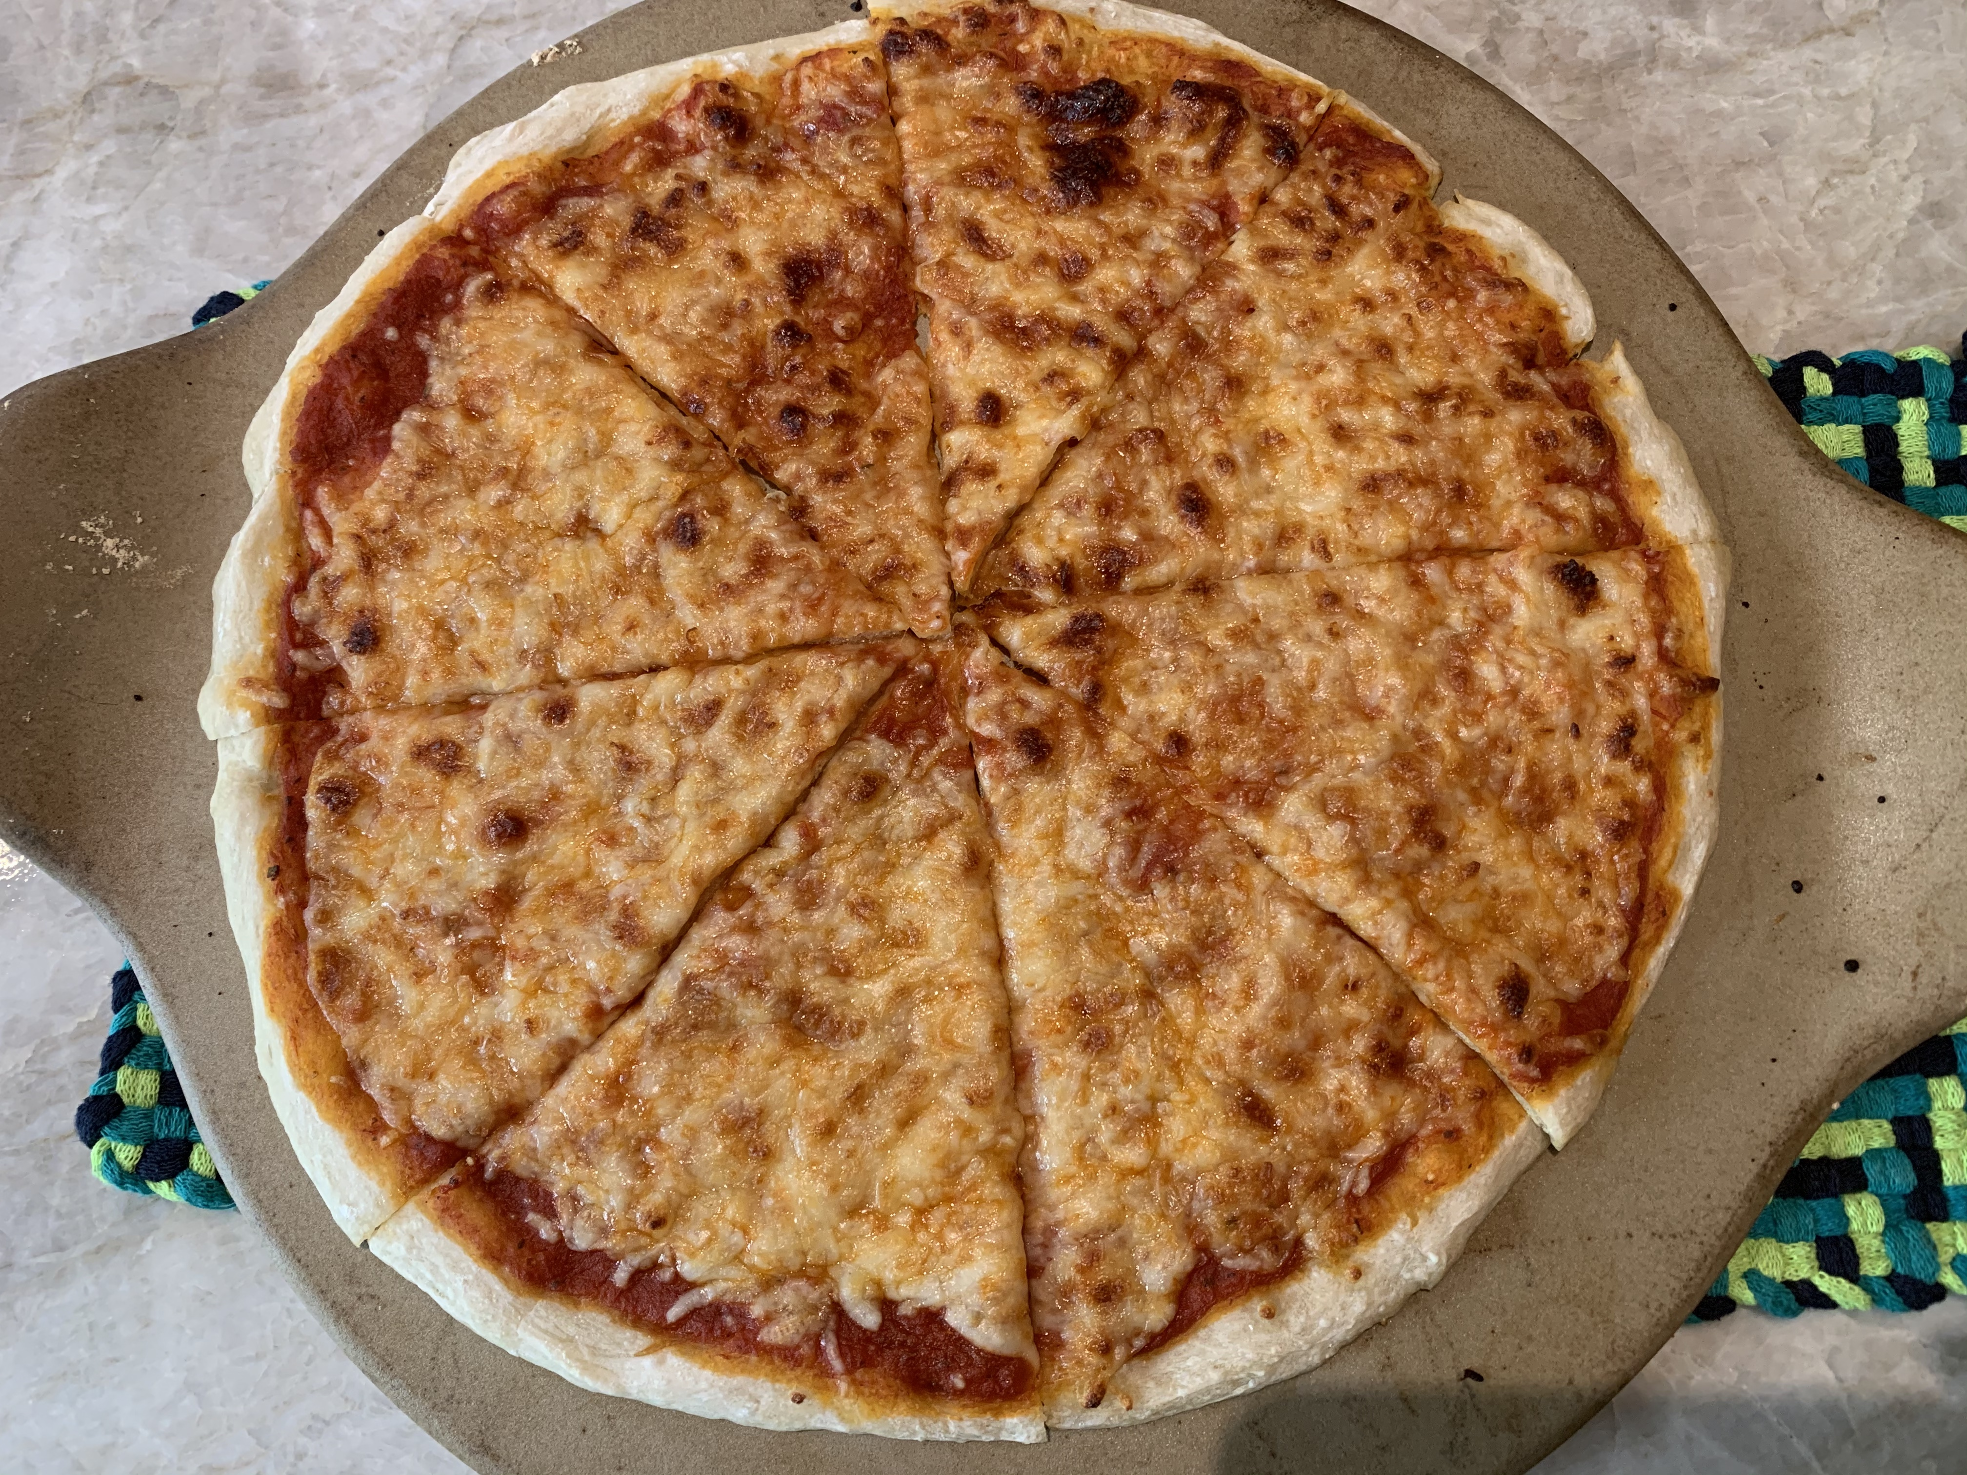
Ingredients

- 2/3 c. warm water
- 1/2 pkg. active dry yeast
- 1/4 tsp. salt
- 2 cups flour
- 2 tsp. vegetable oil

Directions

- Put yeast and warm water in liquid measuring cup.
- Dissolve by stirring with spoon.
- Pour into stand mixer bowl.
- Add salt
- Add 1 cup of flour and mix by hand with spatula.
- Add 2nd cup of flour and mix by hand with spatula.
- Using the dough hook attachment and the mixer on 1st speed, knead for 10 minutes or until smooth and elastic. If dough is too dense, and ½ tsp water, if dough is too sticky add 1 tsp of flour at a time. Dough should not stick to mixing bowl, but should be attached to hook.
- If mixing by hand, flour the surface and knead for 10 minutes or until smooth and elastic.
- Coat dough in oil. Place dough into a covered bowl and let rise in a warm place for 1 ½ hours. If going to freeze for future, place in plastic bag and label and freeze for future use.

Easy Pizza Sauce - Yield: Sauce for 4 Pizzas
Ingredients
- 2 (15 ounce) can tomato sauce
- 1 (6 ounce) can tomato paste
- 1 tablespoon oregano
- 1 tablespoon dried minced garlic
Directions

- In a medium bowl, mix together tomato sauce and tomato paste until smooth.
- Stir in oregano and garlic.

Making the Pizza - – Yield: One 14 inch Pizza

Ingredients

- 1 Tbsp Vegetable Oil
- Prepared pizza dough (risen and room temperature)
- 1 cup pizza sauce
- 1 Tbsp of Parmesan Cheese (optional)
- 1 cup shredded mozzarella cheese
Directions

- Preheat oven to 475 degrees. (Rack at lowest level)
- Lightly grease bottom of 14 in pizza pan, pizza stone, or cookie sheet
- Stretch / roll dough and place on greased pizza pan.
- Add sauce to cover dough leaving about 1/2 inch of dough at the edges.
- Sprinkle parmesan cheese (optional.)
- Sprinkle mozzarella cheese.
- Bake 10-15 minutes or until cheese is melted and crust is lightly browned on the lowest rack of the oven. ** Check at 10 minutes as all ovens cook differently.)
- Remove pizza from pan. Cut and serve. Enjoy! ! !

